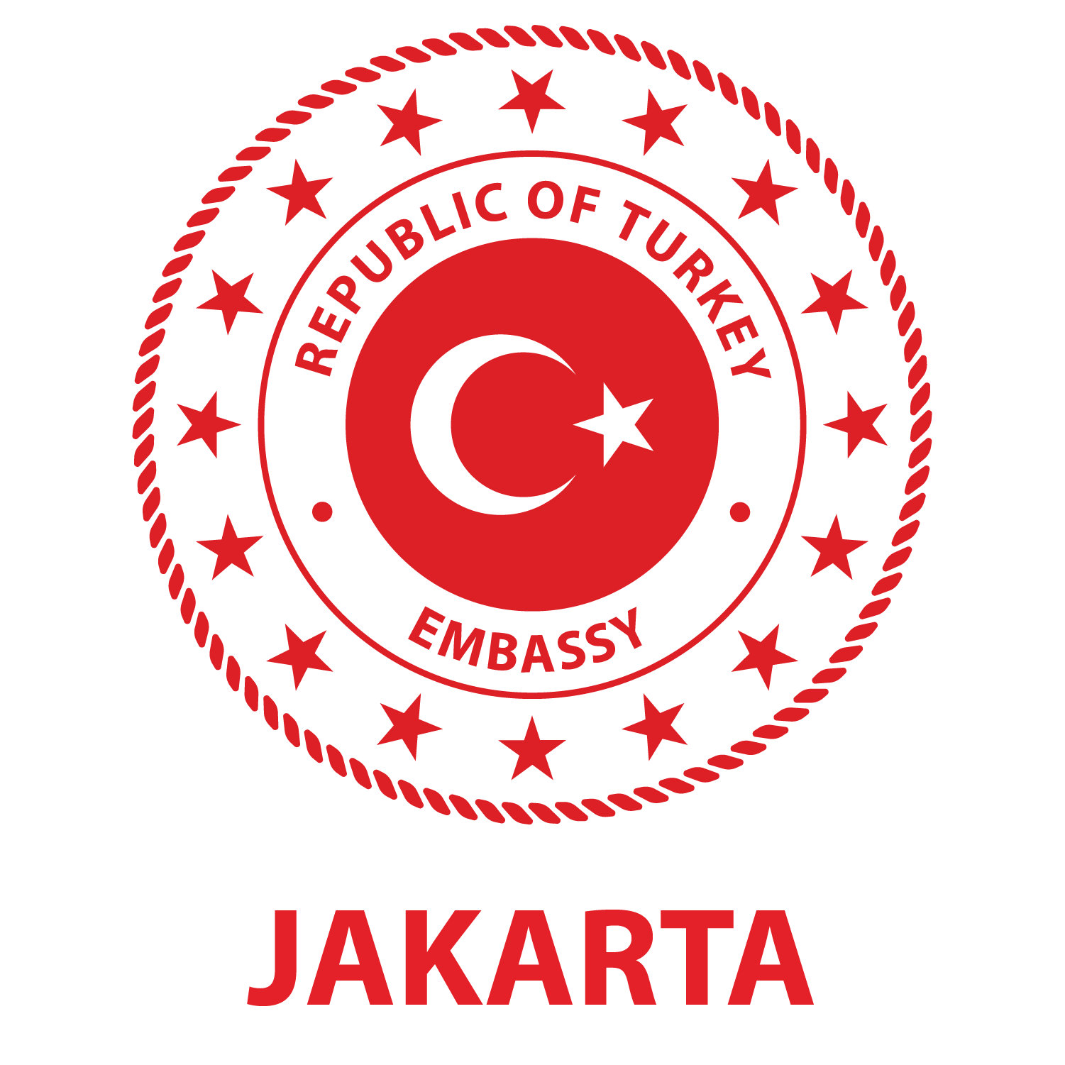

ANNOUNCEMENT TO THE TRAVELLERS TO TURKEY REGARDING COVID-19 MEASURES

Due to the increase in the number of Covid-19 cases all over the world, in order to control the number of cases our official authorities have been taken the following measures:
In accordance with the decisions taken by the official authorities as of 29 December 2020 21:00 (UTC) hours all passengers by air and as of 30 December 2020 all passengers by land/sea that are 6 years old and older will be required to submit a negative SARS-CoV-2 PCR test result done within the last 72-Hours prior to their entrance to Turkey.
Passengers who do not submit a negative SARS-CoV-2 PCR test result (in print or as digital media) taken in the last 72 hours before the flight time will not be admitted to the flight. The announcement regarding the last information on this issue can be reached through the website of Turkish Airlines (Link: https://www.turkishairlines.com/en-us/index.html)
On the other hand, passengers who do not show the negative SARS-CoV-2 PCR test result at the border will be quarantined at the address (house, hotel etc.) that they declare to stay. Those who do not declare address in Turkey will be quarantined at the places selected by the Ministry of Health of the Republic of Turkey. On the 7th day of the quarantine, those passengers will be tested. Quarantine will be lifted for those having negative test result. Passengers with positive test result will be treated in accordance with the Covid-19 guidelines of the Ministry of Health of the Republic of Turkey.
Furthermore, those passengers who have travelled to Denmark, South Africa and the UK during the last ten days prior to their entry to Turkey and show negative SARS-CoV-2 PCR test result at the border while entering to Turkey will still be quarantined at the address that they declare to stay. Above mentioned quarantine protocols will be applicable as well.
This requirement is applicable also for transit and transfer passengers.
These measures will be in force until 01 March 2021.
Best regards,
Turkish Embassy in Jakarta

